|  |
| --- |
|  |
| Aspen Hospital Tragedies |
|  |
|  |
|  |
|  |

Table of Contents

Game Type 2

Gameplay 2

Aesthetics 4

Narrative 7

# Game Type

The level is designed in Minecraft. Gameplay is single player survival horror. The demographic includes teenagers because of the cartoon violence and graphics.

# Gameplay

Since this would be the game’s first level, the difficulty is easy. The level is a small portion of the mental hospital. Initially, the player spawns inside a small wooden home. There is a crafting table, a furnace, a bed, and little decoration. For the player to teleport inside the hospital, they must approach the bed. Each ground floor hallway is connected to the medium-sized lobby. Narrow but long ground floor hallways exist on the left, middle, and right side of the lobby. The basement is large but has physical obstacles. Consequently, the optional challenge induces claustrophobia. However, the design allows for various movements. The upper floor is a narrow but long hallway with one small control room on each side.

When the player approaches the bed, they are teleported to a small and minimalistic cell. Initially, the player has slow movement. A chest is hidden behind a hole in the wall. The player right clicks the chest to grab the stone button and pickaxe. Once the button is placed near the iron door, they escape their cell. Next, the player opens a cell to find a hidden iron sword. Before the player finds the sword, they may either hide to avoid detection or run to every cell. Few cells have food and health potions to aid their journey. The player must slay the guard with the sword. Upon the guard’s death, a keycard drops. When the player approaches the hallway exit with the keycard in hand, they can exit the hallway. Afterwards, the player must enter the left and right hallways. Once they find a stair piece, they place it to ascend the next floor. Before the player may enter the left side control room, they must have an admin keycard in hand. Inside the control room, the player obtains the master keycard. The player may press a stone button to activate the optional ghost trap event. If the player chooses to perform the event, the basement door will open. Next, the player descends the basement stairs. The player lures the ghost inside a bloody trap. If successful, the ghost disappears, and the player has normal movement speed. Otherwise, the player can run across the hallway to enter the master control room. Upon button press, blocks are removed from the middle wall to reveal an iron golem boss. While the boss chases the player, they must enter the boss room to remove the button. If the player is observant, they can enter an open vent to escape without the key. Otherwise, the player rushes toward the exit doors to evade the boss. The button is placed near an exit door to escape. If the player follows the critical path, the level should take 15 minutes to complete.

Upon level start, the player should know how to move, open chests, place/destroy blocks, open iron doors, hide from mobs, kill mobs, eat food, and drink potions. Stone buttons, iron pickaxe, iron sword, flesh, health potions, bones, paper keycards, and written books are in the level. The player can interact with doctor and patient NPCs. In the level, the player finds hidden chests, places/breaks certain items, opens doors with a keycard, and runs from enemies. At the end, the player should proficiently find hidden items, hide or run from enemies, kill mobs to obtain items, unlock doors by holding keycards next to appropriate doors, resource management, and luring an enemy into a trap.

.

The level should make the player feel anxiety, excitement, and intelligent. Unique implementation of visuals, sound, and narrative make the level memorable. Every mechanic and command I need to use is already in the game.

# Aesthetics

Although the level is stylized because of the game, unconventional building methods will push the artistic limits to achieve exceptional details. The building is a mental hospital constructed in the 1900s. Double iron doors lock the exit. The lobby is a mostly clean space. A blue shield rug with a gray outline lies in the middle of the lobby. The stairs and basement door are on the left of the middle hallway. Reception is on the right side. The left, middle, and right hallways are on the ground floor. A hallway connects two control rooms on the upper floor. The left side has the admin control room and hidden vent ladder. On the right side is the master control room. Near the level’s end, the upper middle wall is broken to reveal the boss and key. Red blocks, redstone, bones, and skulls indicate activity. The basement contains a bloody trap in the middle, cells, boxes, and shelves. Gray, blue, and white is the color scheme. Darkness, isolation, and claustrophobia are the intended atmosphere elements. The player should feel anxious, helpless, excited, and intelligent.

The scene is a clear night. Events occur in the overworld, which is Minecraft’s equivalent to Earth. Most of the level is on the ground. However, the player may choose to go inside the underground basement. Player interpretation determines if the world is reality or dream. If events are interrupted as real, the character might have memory loss or hallucinations. The short bed scene may lead the player to interrupt the events as dreams.

Dim lights, blood, NPCs, bones, and the shield rug visually guide the player. Natural mob sounds and artificial screams are the auditory equivalent. Archways frame important areas. The shield rug and basement are visual trademarks. I plan to use existing assets.

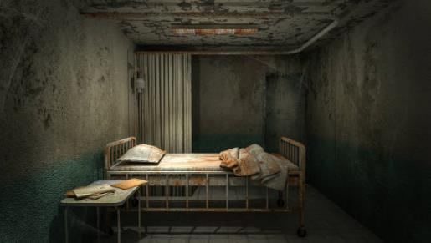

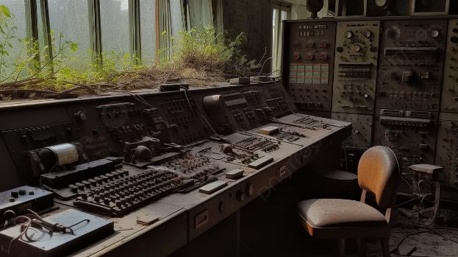

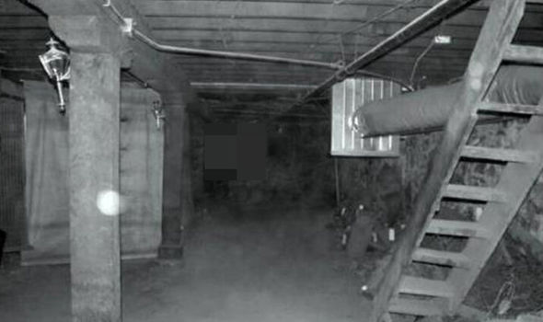

# Narrative

Before the current events, the character has been to other hospitals and prescribed various medications. The scene begins early into the night. After hours of work, the character feels lethargic. The character approaches the bed. Unfortunately, they slowly wake in a cell with nausea. Due to a broken leg, the player is slow. Once the character escapes their cell, they search for a weapon. The character may hide, run from, and/or fight the guard. Upon the guard’s death, the character snatches the keycard to exit the middle hallway. Next, the character obtains a stair piece to fix the stairway. If the character holds the admin control room keycard, they may enter the room. The master keycard is obtained from a hidden chest. Gameplay determines whether the ghost is angered or not. If the ghost is present, the character may choose to use the basement’s trap or avoid conflict. Various medications and tools are stored in the basement. A successful ghost trap heals the character’s broken leg. Otherwise, the character drags themselves into the master control room. A button press reveals the large robot inside the middle wall. The character may dodge the robot to remove the key with a pickaxe. Lastly, they use the key to escape through doors or enter the secret vent.

Most cells have interactable doctor and/or patient NPCs After dialogue, some NPCs disappear to suggest hallucination or death. Other NPCs remain to question the player’s sanity and suggest the events might be real. Most cells have patient journals and/or medical documents. If the player chooses to explore the story, they may discover the character has extra sensory perception. The character questions the accuracy of this claim. Flesh, bones, and liquid medication can be found in most chests.

The character is possibly a current patient at the hospital. Whether reality or dream, the character’s past with mental health disorders led them to be in the facility. As the character navigates the hospital, they attempt to distinguish reality from illusion. Fear and confusion motivate their escape.

In the game’s world, the hospital is real. The hospital was constructed in the 1900s. People with severe mental health disorders were sent here for treatment. Instead of proper treatments, doctors conducted tests to learn about the patients. Although living conditions were unpleasant, they gradually improved over the decades. Dozens of deaths and hundreds of significant injuries occurred in the building. The character’s experiences could be real, imagination, or somewhere in-between.